NAME: KAVITAPU SWARNA VARSHINI
REG.NO: 192324081
DATE: 14-07-2026

Write a python program for Alpha-Beta Pruning Algorithm for Gaming
AIM: To write a Python program to implement the Alpha-Beta Pruning Algorithm for optimizing the Minimax search in a two-player game.
ALGORITHM:
- Represent the game tree with terminal node values.
- Initialize Alpha = -∞ and Beta = +∞.
- Traverse the game tree using the Minimax approach.
- Prune branches whenever Alpha ≥ Beta to avoid unnecessary evaluations.
- Display the optimal value obtained after the search.
CODE:
scores = [3, 5, 6, 9]

def alphabeta(depth, node, alpha, beta, isMax):
if depth == 2:
return scores[node]

if isMax:
value = -999
for i in range(2):
value = max(value, alphabeta(depth + 1, node * 2 + i, alpha, beta, False))
alpha = max(alpha, value)
if alpha >= beta:
break
return value
else:
value = 999
for i in range(2):
value = min(value, alphabeta(depth + 1, node * 2 + i, alpha, beta, True))
beta = min(beta, value)
if alpha >= beta:
break
return value

print("Optimal Value:", alphabeta(0, 0, -999, 999, True))
OUTPUT:
Optimal Value: 5
IMAGE:

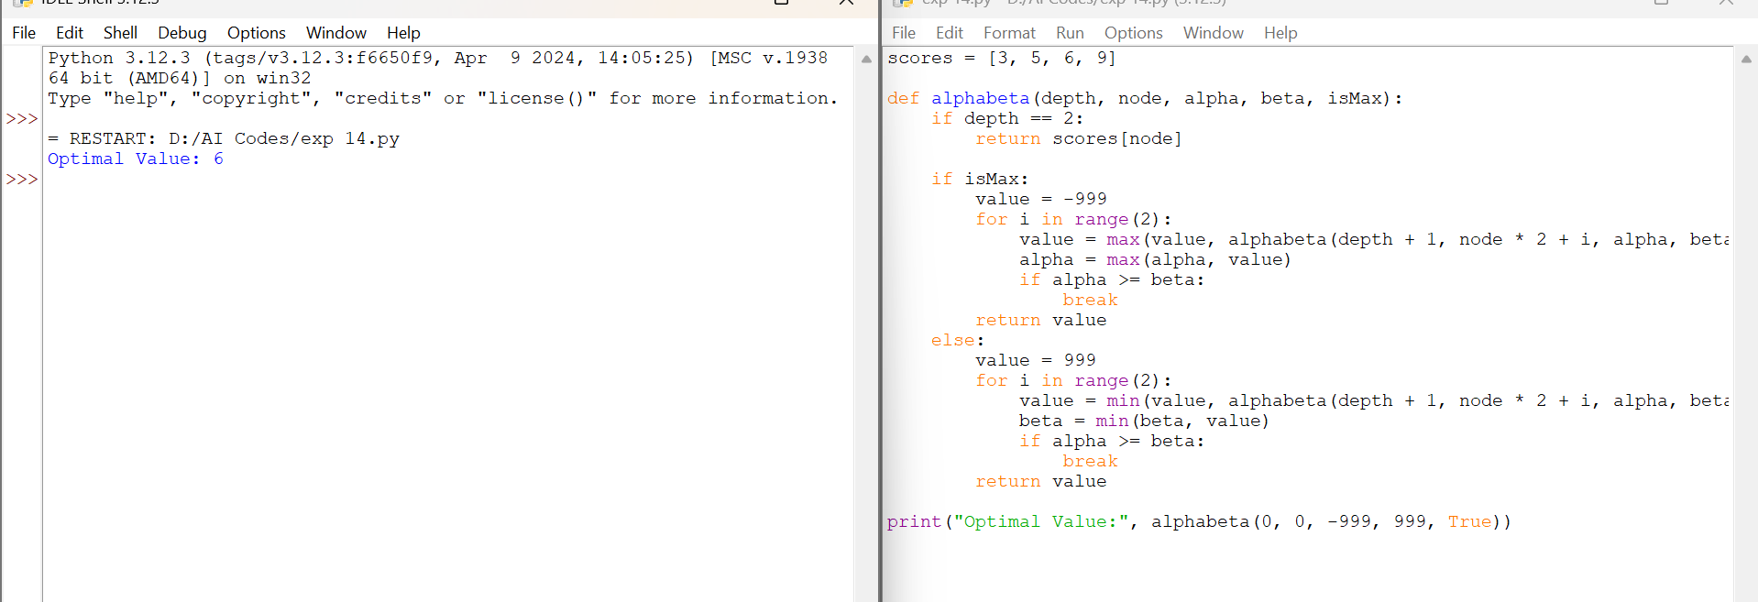
RESULT:
The Python program successfully implemented the Alpha-Beta Pruning Algorithm. It efficiently reduced the number of nodes evaluated by pruning unnecessary branches while producing the same optimal result as the Minimax Algorithm.

